JAWAHARLAL NEHRU UNIVERSITY
SCHOOL OF COMPUTER AND SYSTEM SCIENCES
NEW DELHI – 110067

PROJECT DOCUMENT
ON
SMART APPOINTMENT BOOKING SYSTEM
(Service-Oriented Architecture Based Web Application)

Submitted By
Name: Praduman Jaiswal
Enrollment Number: 25/10/MT/021
Course: M.tech in Computer Science and Technology
Semester: II

Submitted To
Prof./Dr. Poonguzhali N
School of Computer and System Sciences
Jawaharlal Nehru University

Smart Appointment Booking System
A Service-Oriented Architecture Based Web Application Project Report

Abstract
The Smart Appointment Booking System is a web-based application designed to simplify appointment scheduling between users and service providers such as doctors, consultants, or salons. Traditional booking systems often rely on manual processes that are time consuming and inefficient. This system provides an online platform where users can view available providers, select time slots, and schedule appointments easily.
The application follows a Service-Oriented Architecture (SOA) where the system is divided into independent services such as authentication service, provider service, booking service, payment service, and notification service. Each service communicates through APIs which improves scalability and maintainability. The system uses modern full stack technologies to provide a responsive and efficient solution.

Introduction
Digital platforms have transformed the way services are delivered in many industries. Appointment based services such as healthcare, consulting, and personal care require efficient scheduling systems to avoid conflicts and reduce waiting times.
The Smart Appointment Booking System allows users to register, search for service providers, and book appointments online. Service providers can manage their schedules and track appointments. The use of service oriented architecture allows the system to be modular, scalable, and flexible.

Objectives
1. To design an online system for appointment scheduling.
2. To reduce manual work involved in managing appointments.
3. To implement service oriented architecture in a web application.
4. To provide a user friendly interface for users and providers.
5. To improve efficiency and reduce appointment conflicts.

System Architecture
The system architecture follows the SOA model. The application is divided into multiple services that communicate through REST APIs.
Main components include:
Frontend Application (React)
API Gateway
Authentication Service
Provider Service
Booking Service
Payment Service
Notification Service
Each service performs a specific task and has its own database or data storage mechanism.

Technology Stack
Frontend: React.js, HTML, CSS, JavaScript
Backend: Node.js with Express.js
Database: MongoDB
Communication: REST APIs
Tools: GitHub, Docker (optional)

Modules
User Module – registration, login, booking appointments.
Provider Module – manage provider details and availability.
Booking Module – handles scheduling and appointment records.
Payment Module – processes payments.
Notification Module – sends reminders and confirmations.

Database Design
Users Table: id, name, email, password, role
Providers Table: id, name, specialization, availability
Appointments Table: id, user_id, provider_id, date, time, status

System Architecture Diagram (SOA)
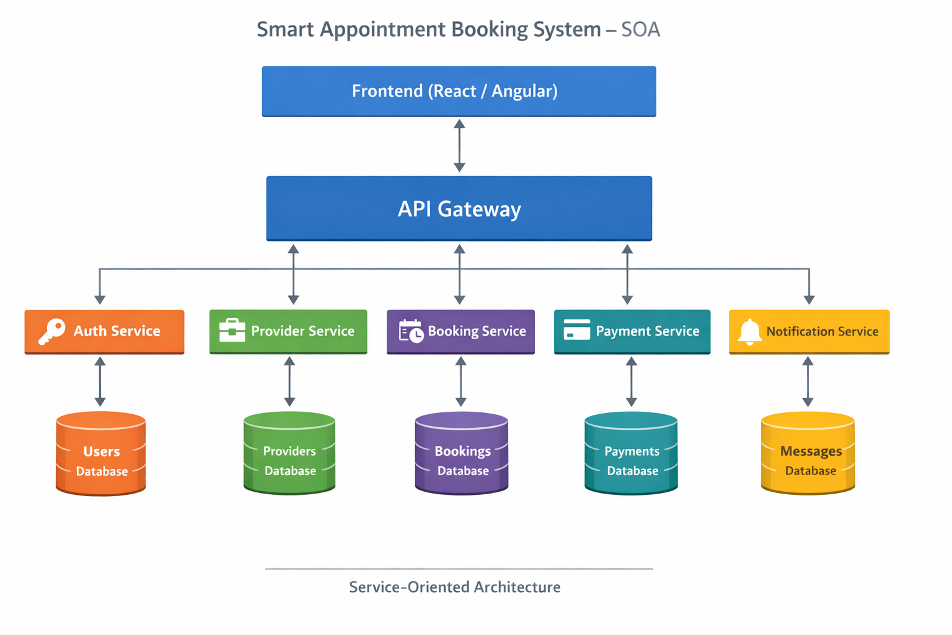
.

UML Diagrams

Use Case Diagram
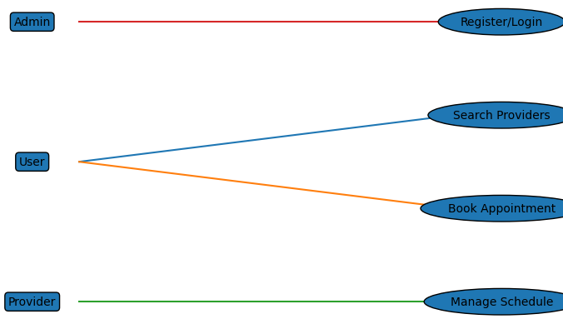

Class Diagram

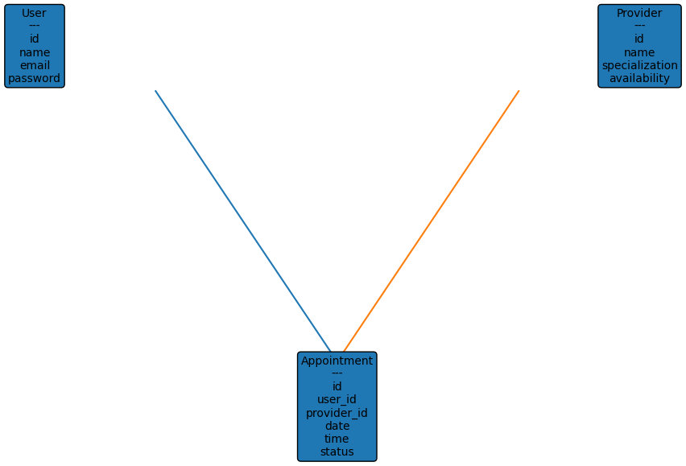

Sequence Diagram
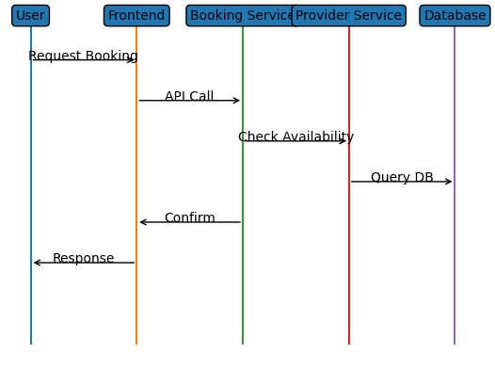

Activity Diagram
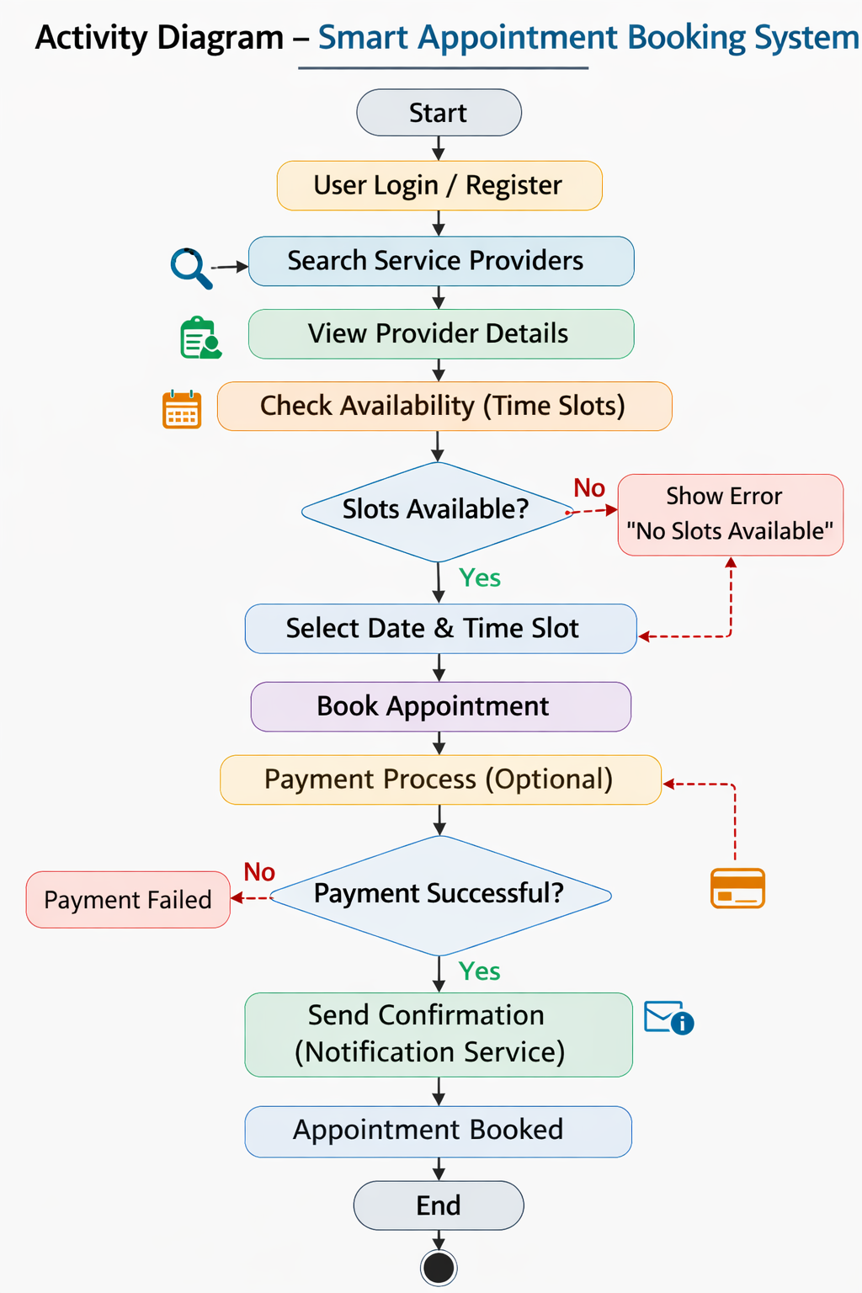

Advantages
• Easy appointment scheduling
• Saves time for users and providers
• Prevents double bookings
• Scalable architecture
• Improved user experience

Future Scope
Future improvements may include mobile applications, AI based recommendations, integration with Google Calendar, push notifications, and advanced analytics dashboards.

Conclusion
The Smart Appointment Booking System demonstrates how modern web technologies and service oriented architecture can be used to build scalable and efficient applications. The system improves scheduling efficiency and provides a convenient platform for users and service providers

